**Assignment 10.4**

**Problem Statement :**

1.Write a pig script find the average age of male and female persons died in the titanic tragedy

2.Write a pig script to find the number of people died and survived in each class.

**Input:**

You can download the dataset from the below link Titanic_Data_Set

**Program:**

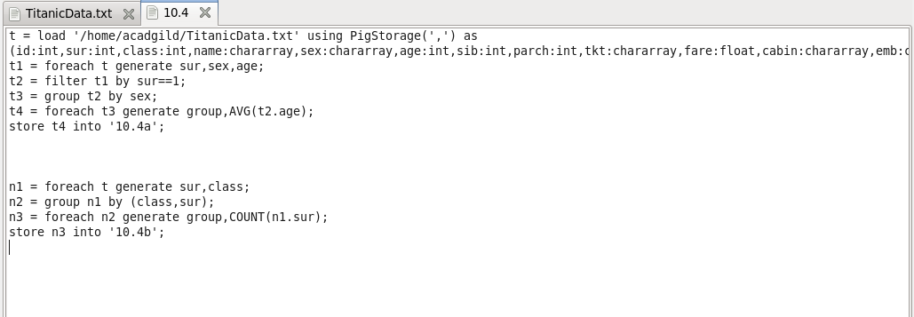

**Output:**

